**Task sheet A+**

**Task 1: Create a diagram of a PC with labeled hardware components:**

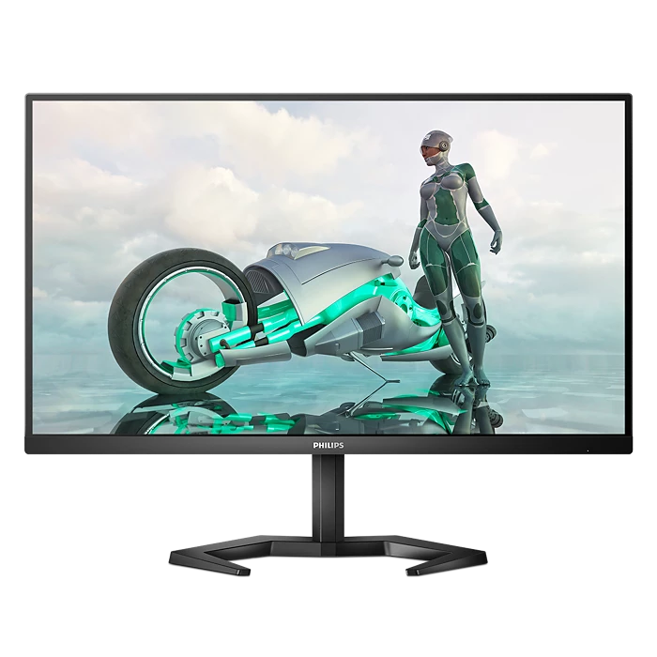

**Monitor**

Monitor

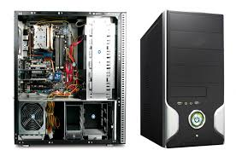

CPU cabinet with Components

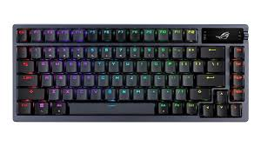

**Keyboard**

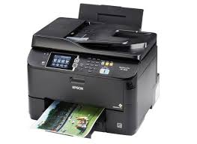

Printer

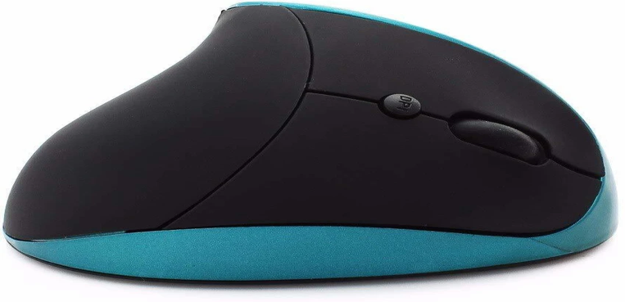

**Mouse**

**Task 2: Assemble and Disassemble a Desktop PC**

Purpose: This guide outlines the safe and correct steps for assembling and disassembling a desktop computer.

Tools Required: Phillips-head screwdriver, anti-static wrist strap, thermal paste (if required), cable ties.

# A. PC ASSEMBLE STEPS

## Step 1: Prepare the Workspace

Use a clean, flat surface. Wear an anti-static wrist strap to prevent ESD damage.

## Step 2: Install the Power Supply (PSU)

Align the PSU with the mounting holes in the case. Secure it with screws. Route the cables through the cable management area.

## Step 3: Install the CPU on the Motherboard

Open the CPU socket latch. Align the CPU (triangle mark) with the socket. Place it gently and close the latch.

## Step 4: Apply Thermal Paste (if needed)

Apply a pea-sized drop of thermal paste to the center of the CPU (skip if the cooler comes with pre-applied paste).

## Step 5: Install the CPU Cooler

Mount the cooler onto the CPU. Lock it in place using the retention mechanism. Connect the CPU fan header to the motherboard.

## Step 6: Install RAM Modules

Open the DIMM slot latches. Align the RAM notch with the slot. Firmly press down until the latches click.

## Step 7: Mount the Motherboard in the Case

Install motherboard standoffs in the case. Align the motherboard with the I/O shield and standoffs. Screw the motherboard in place.

## Step 8: Install Storage Devices (SSD/HDD)

Mount the drives in appropriate bays (2.5" or 3.5"). Secure them with screws or tool-less brackets. Connect SATA data and power cables.

## Step 9: Install the Graphics Card (GPU)

Remove PCIe slot covers as needed. Insert the GPU into the PCIe x16 slot. Secure it with screws. Connect PCIe power cables from the PSU if needed.

## Step 10: Connect Front Panel Connectors

Power switch, reset switch, HDD LED, and front USB/audio. Refer to the motherboard manual for correct pin placement.

## Step 11: Connect Power Cables

24-pin ATX power to motherboard. 8-pin CPU power. SATA power to drives. PCIe power to GPU.

## Step 12: Perform a Power-On Self Test (POST)

Plug in monitor and keyboard. Power on the system and check for display output and BIOS access.

## Step 13: Cable Management and Final Check

Route cables neatly using cable ties. Close side panels and secure with screws.

# B. DISASSEMBLY STEPS

## Step 1: Power Off and Unplug

Shut down the PC. Unplug the power cable and all peripherals.

## Step 2: Open the Case

Remove side panels by unscrewing or sliding them off.

## Step 3: Disconnect Power Cables

Unplug 24-pin, 8-pin CPU, SATA, and GPU power cables.

## Step 4: Remove Front Panel Connectors

Gently unplug USB, audio, and front panel connectors.

## Step 5: Remove GPU

Unscrew and release GPU latch. Carefully pull GPU out of the PCIe slot.

## Step 6: Remove Storage Devices

Unplug SATA data/power. Unscrew or unclip SSD/HDD drives.

## Step 7: Unscrew and Remove the Motherboard

Unscrew motherboard from standoffs. Carefully lift out the board with CPU, cooler, and RAM still attached.

## Step 8: Remove RAM Modules

Open latches on each side and pull RAM sticks out gently.

## Step 9: Remove CPU Cooler

Disconnect fan header. Unscrew or unlatch the cooler from the socket.

## Step 10: Remove CPU

Lift the CPU socket latch. Gently remove the CPU without touching the pins.

## Step 11: Remove the PSU

Unscrew PSU from the case and pull out all cables.

## Step 12: Clean and Store Components

Use anti-static bags. Organize screws and parts for reassembly or storage.

**Task 3: Write a report on how to set up and test a basic network.**

**Components Required :**

* Router or wireless access point
* Network switch (for wired networks)
* Ethernet cables (Cat5e or Cat6)
* Computers or laptops
* Wireless adapters (for wireless setup)
* Internet connection (optional)

**Step-by-Step Network Configuration Guide:**

**Step 1: Physical Setup**

* **Connect the Router:**

Plug the router into a power source.

Connect the router's WAN/Internet port to the modem (if internet is needed).

Connect one PC to a **LAN port** of the router using a Cat6 cable.

* **Wired Devices:**

Use Ethernet cables to connect PCs/laptops to the LAN ports of the router or switch.

* **Wireless Devices:**

Turn on Wi-Fi on the device.

Connect to the router’s SSID (Wi-Fi name) using the correct password.

**Step 2: Configuration**

1. **Find Router IP:** Open a web browser on a connected computer and enter the router’s IP address. Common router IPs include “192.168.0.1” or “192.168.1.1.” Consult your router’s manual for the specific IP.
2. **Login:** Log in to the router’s administration interface using the default username and password (usually “admin” and “admin” or “admin” and “password”). Change the password for security.

**Step 3: Configure Basic Settings**

* change default SSID and Wi-Fi password.
* Ensure DHCP is enabled (for automatic IP assignment).
* Optionally configure MAC filtering, port forwarding, or parental controls.

**Step 4: Security Settings**

* Use **WPA2 or WPA3 encryption**.
* Disable WPS for better security.
* Change default admin password.
* Enable the router’s firewall to protect your network from external threats.

**Step 5: Network Testing**

**A**. Check IP Addressing:

* Run ipconfig (Windows) or ifconfig (Linux/macOS).
* Confirm the device received an IP in the 192.168.x.x or 10.x.x.x range.

**B**. Test Local Connectivity:

* Ping Another Device:

ping 192.168.1.5

* Confirms Layer 3 communication between hosts.
* Ping the Router (Default Gateway):

ping 192.168.1.1

**C**. Test Internet Connectivity:

* DNS and Internet Test:

ping google.com

* Trace Route:

tracert google.com

Verifies the number of hops between the PC and the destination server.

**D.** Share a Resource (Optional):

Create a shared folder on one PC.

Access it from another via:

\\ComputerName\SharedFolder

By following the above steps, a basic wired or wireless LAN can be successfully set up. Proper testing using built-in utilities like ping, tracert, and browser tools confirms network functionality. This network can now support file sharing, internet access, and printer sharing.

**Task 4: Checklist for diagnosing hardware issues.**

**Hardware Troubleshooting Checklist (Enhanced Format)**

|  |  |  |  |
| --- | --- | --- | --- |
| **Section** | **Checklist Item** | **Status (✓/✗)** | **Remarks/Notes** |
| **Initial Inspection** | Is the computer turning on (Power LED, fan spin)? |  |  |
|  | All power/data cables connected securely? |  |  |
|  | Are there any beep codes or POST messages? |  | Use motherboard manual for codes |
|  | Visible damage or loose hardware? |  | Burn marks, bent pins, etc. |
|  | Unusual sounds (clicking, grinding, no fan spin)? |  | Could indicate HDD/PSU issue |
| **Power Supply (SMPS)** | Is the power supply fan running? |  |  |
|  | Voltage output tested with multimeter? |  | +12V, +5V, +3.3V lines |
|  | Tried using a known-good power supply? |  |  |
| **Motherboard & CPU** | CPU seated correctly with thermal paste applied? |  |  |
|  | CPU fan/heatsink functioning properly? |  |  |
|  | Any swollen capacitors or burnt smell on motherboard? |  |  |
|  | BIOS/UEFI reset performed (CMOS clear)? |  |  |
| **RAM (Memory)** | RAM modules firmly seated in slots? |  |  |
|  | Tested each module individually? |  |  |
|  | Memory diagnostics passed (MemTest86 or built-in tool)? |  |  |
| **Storage (HDD/SSD)** | Drive detected in BIOS/UEFI? |  |  |
|  | SATA/power cables connected or swapped/tested? |  |  |
|  | Run CHKDSK or manufacturer disk tool? |  |  |
| **Display/GPU** | Monitor powered and correctly connected? |  | Test VGA/HDMI/DP cables |
|  | Display output from GPU or onboard video checked? |  |  |
|  | GPU properly seated and fan spinning? |  |  |
|  | Tried a different monitor or GPU? |  |  |
| **Ports & Peripherals** | Disconnected all external devices before boot? |  |  |
|  | USB ports tested with working device? |  |  |
|  | Mouse/keyboard tested on another system? |  |  |
| **Cooling & Temps** | All fans spinning (CPU, case, GPU)? |  |  |
|  | Cleaned dust from heatsinks, vents, and fans? |  |  |
|  | CPU/GPU temps checked (BIOS/HWMonitor)? |  |  |
| **Tools Used** | POST card or diagnostic LED error codes checked? |  |  |
|  | Multimeter tested key power rails? |  |  |
|  | Booted diagnostic USB (Hiren's, UBCD, etc.)? |  |  |
| **Documentation** | Symptoms and troubleshooting steps documented? |  |  |
|  | Noted any hardware/software changes before issue? |  |  |
|  | Resolution steps and parts replaced recorded? |  |  |